Frequently Asked Questions
New pedestrian and cycle bridge across the Grand Union Canal Paddington Arm in Alperton

Q1 - Is there a need for a new pedestrian and cycle bridge over the Grand Union Canal Paddington Arm at Alperton?
A1 - Alperton is a strategic growth area under the Brent Local Plan. The Alperton housing zone has delivered 1,500 new homes over the past ten years and is expected to add 7,800 new homes by 2041. Building the bridge at this location will support this growth by improving transport links and encouraging active travel.

The Alperton Transport Assessment in 2018 identified the delivery of a new pedestrian and cycle bridge across the Grand Union Canal from the former Northfields Industrial Estate, now known as the Grand Union development, as providing a major boost to walking and cycling access across the area. There is an existing bridge across the canal in the area, however this is not fit for purpose.

Q2 - Where exactly will the proposed bridge be located?
A2 - The location of the proposed bridge is to the southern extent of the Grand Union development, which lies between the North Circular Road and Beresford Avenue on the east bank of the Grand Union Canal. The bridge will be located at the point where the River Brent passes under the Grand Union Canal. The bridge will land on the southwestern side of the canal in Hanger Hill, Ealing. The red circle on figure 1 shows the location of the proposed bridge. The nearest postcode is HA0 1SY
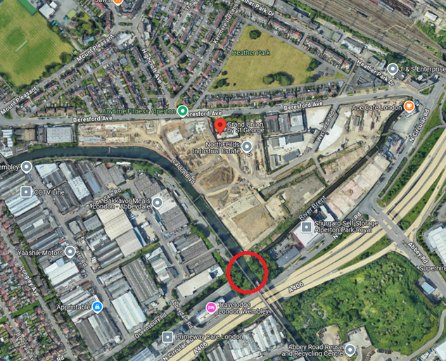
Figure 1 : Location of Proposed Bridge Crossing (© 2025 TomTom, © OpenStreetMap, © Vexcel Imaging)

Q3 - Why was the proposed location chosen?
A3 - Fourteen potential options were considered for the new pedestrian and cycle bridge at different locations along the Canal including a bridge lift. After considering all the constraints and requirements within the sites and having carefully considered the advantages and disadvantages of all options, the preferred location for the proposed bridge, at the south end of the new Grand Union development, was identified as the most suitable location.

The use of this site allows us to build a simple, compact and symmetrical bridge, to give the area a crossing with access and egress at the same location either side of the canal.

Q4 - Why can’t the existing bridge be upgraded?
A4 - The existing footbridge across the canal at Grand Union on the former Northfields Industrial Estate doesn’t meet modern accessibility standards and is inaccessible to the public as it lands on a private industrial facility, behind a fence running along the towpath. It also cannot accommodate the required ramp infrastructure without significant cost and disruption and therefore proposing a new pedestrian and cycle bridge is a better option.

Q5 - Will the existing bridge be demolished?
A5 - There is no proposal to demolish existing bridges as part of this scheme.

Q6 – What are the benefits of building the new bridge?

A6:

Improving access and connectivity in the area:
The bridge will create a direct east-west route for pedestrians and cyclists, linking the Grand Union development to the towpath and improving access to Alperton and Stonebridge Park stations, and to local employment areas including Park Royal.

Promoting active travel and wellbeing:
The new bridge will provide a safer and more direct route connecting the Grand Union development to the popular towpath on the western bank of the canal, Abbey Estate and the shops beyond. Cyclists can use the bridge without having to dismount. The new bridge will reduce journey times between Alperton and Stonebridge Park stations and increase opportunities for active travel, promoting better health and wellbeing and easier access to the waterside.

Benefitting the local environment:
The new bridge will reduce environmental transport impacts by encouraging more walking and cycling, which will reduce air pollution. Existing invasive species like giant hogweed at the proposed bridge location will be removed and replaced with significant native planting to improve local biodiversity.

Ensuring pedestrian and cyclist safety, and accessibility for people with disabilities while using the bridge:
The proposed bridge is compliant with UK standards for new cycle and pedestrian bridges (Design Code CD 353) to ensure it is safe for users and the general public. Parapets are also designed to UK standards to provide no large gaps that may cause a safety issue. The parapet has an inclined design which is hard to climb, to discourage antisocial behaviour.

The design requirements for ramps have been evaluated so that the structure is accessible for people on bicycles, with pushchairs and users with mobility or sensory impairments. If there is sufficient space available, stairs should also be provided to allow a more direct route over the structure for users on foot.

Q7 - Will the towpath be out of bounds during construction? When will this be and how long for?
A7 - It is anticipated that a temporary closure of the Grand Union Canal towpath will be required for short durations. The intention is for a towpath access to be maintained for most of the duration of the works where safe and practical.
It is anticipated that a temporary closure of the Grand Union Canal waterway will also be required for a short period for lifting in and installing the steel bridge structure.
We will keep the public informed well in advance of any closures that could impact them, to help them plan ahead.

Q8 - What visual impact can we expect from the new bridge?
A8 - We will be mindful that the bridge considers the Grand Union Canal setting and works well with any future towpath improvements and other enhancements to the public facilities in the area. We want to build a beautiful bridge that belongs to the area.

We will use low-maintenance materials for the bridge to minimise future work and promote sustainability.

Q9 - What towpath improvements are being planned?
A9 - In 2021, the Council contributed £169,783.23 of s106 to improve the towpaths as part of Canal & River Trust wider Grand Union Canal quietway project. No additional towpath improvements are planned as part of the scheme other than the removal of invasive species and planting adjacent to the towpath.

Q10 - How will the bridge affect the nearby trees and how many trees will need to be removed, if any?
A10 - We understand the importance of trees and green spaces to the area, and a key consideration will be the protection of surrounding trees including the structure of the soil in which they grow. Where trees of quality need to be removed to build the bridge safely, we will seek the advice of an arboriculturist to achieve the best possible outcomes for the preservation of trees – this could mean replanting new trees in keeping with those we would need to remove, as planning policy requires.

We estimate that less than 10 young to early mature Sycamore and Norway Maple trees may need to be felled as part of the scheme. We would seek to retain the wood on site to contribute to woodland biodiversity. We are not proposing to fell any ancient or veteran trees and will endeavour to re-plant more trees than are felled as part of the scheme.

Q11 - Removal of invasive species
A11 - A preliminary ecological appraisal has confirmed that giant hogweed is present on the north bank of the Grand Union Canal. Giant hogweed is an invasive non-native species that poses a serious health risk to people and pets. Touching Giant Hogweed can cause severe and long-lasting skin damage. Japanese knotweed and buddleia were also found on an adjacent site.

An Invasive Non-Native Species Management Plan detailing suitable removal, mitigation and disposal measure for giant hogweed, buddleia and Japanese knotweed will be created once planning permission has been secured for the bridge construction.

Q12 - How will you protect the historically important pillbox?
A12 - The Second World War pillbox at the proposed site will be retained and will not be removed or altered as part of the proposed scheme. The proposed bridge location is set back from the pillbox to discourage climbing and anti-social behaviour.

Q13 - How is the bridge funded?
A13 - The footbridge is funded through the Strategic Community Infrastructure Levy (SCIL) money collected from developers when they build new homes. This funding is specifically ring-fenced for infrastructure projects that benefits the community. See here for detailed information about the funding of this project.

Q14. When will the bridge be built?
A14 - The bridge is planned for construction in Winter 2026, subject to securing planning permission and finalising necessary land agreements.

Q15. How to stay informed or ask questions about the project.
A15 - Email: GUCbridgeconsultation@brent.gov.uk; Phone: 020 8937 3630

ENDS

